**Institute of Technology Tralee**

**BSc. in Computing with Specialism (Group 1) - Year 1**

**Continuous Assessment #1**

**Date: 6/11/14**

**Time: 2 – 4 p.m.**

**Introduction to Programming**

**Instructions:** Attempt the following question. You should use the JCreator IDE for coding. When you are finished you must print out your code for correction.

**________________________________________________________**

**Q1.**

Write a Java program that first of all prompts for and reads in the first name and surname of a person (these will be entered separately and you can take it that the first letter of both first and surname will always be entered in uppercase). Once this is done, the first name will be converted to lowercase and a test will be performed on this lowercase version of the first name entered to see if it matches the string “patrick”. If the first name entered matches “patrick” then the surname will be tested to see if it begins with the letter capital ‘K’. If the first name entered does not match “patrick” then the program will not test the surname at all and simply issue the message “Your first name was not Patrick so we didn’t bother testing the surname”. If it turns out that the lowercase version of the first name entered matches “patrick” and the surname begins with the letter capital ‘K’ then the program will simply issue the message “Your first name was “Patrick” and your surname begins with a ‘K’”. If it turns out that the lowercase version of the first name entered matches “patrick” but the surname does not begin with the letter capital ‘K’ then the program will issue the message “Your first name was “Patrick” but your surname does not begin with a ‘K’”.

After this the program should display the initials of the person and also state whether or not the initials are the same.

Using the test values as indicated in the screen shots below, the program should give you **exactly** the following output when it runs, including any banners, blank lines etc. Note in the banner there are exactly **40 asterisks** and that the text “Name Tester” should be displayed using a field-width of **25 spaces** in a **right-justified** manner in order to get it approximately centered in the banner.

Also note that there will be a few marks awarded for the use of **meaningful variable names**, having a **single and multi-line comment at the top of the program** and for **proper indentation** in the coding of the program.

**Sample Screen Shots**

**The user enters “Michael” and “Mahoney”**

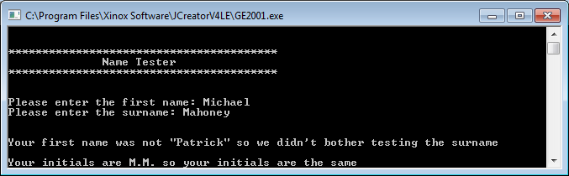

**The user enters “PATRICK” and “Mahoney”**

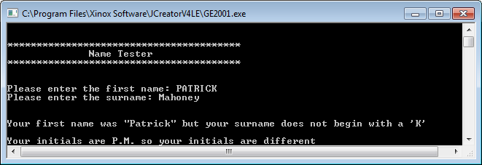

**The user enters “PATRICK” and “kelly”**

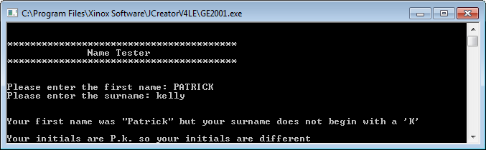

**The user enters “PATRICK” and “Kelly”**

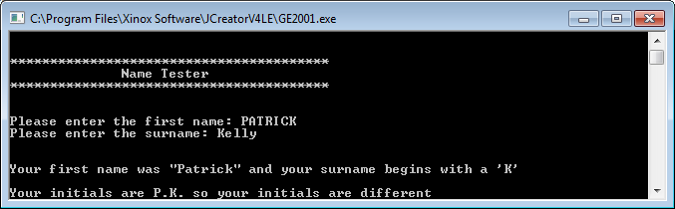

**The user enters “Patrick” and “Peters”**

